Dodecahedron
# Source: AI Source: Provided by: [Data Path: Persons Table -> ID Column: 1, Name_En Column: Motasem Essam] -> From: [ChatGPT] on [7/25/2026]
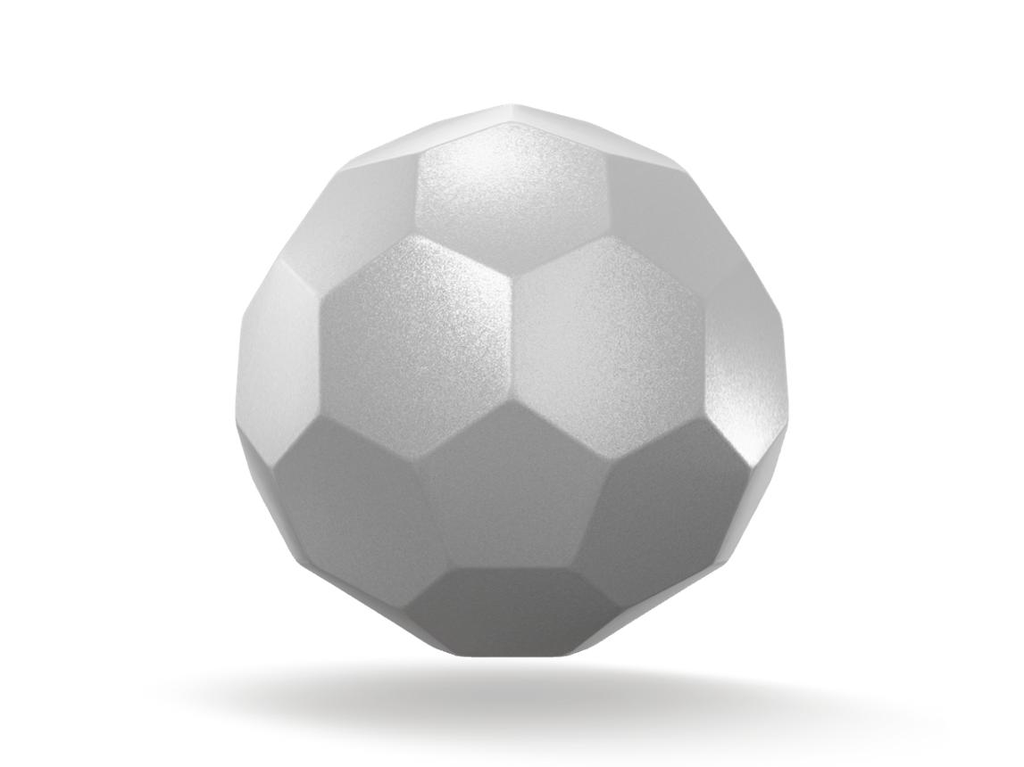
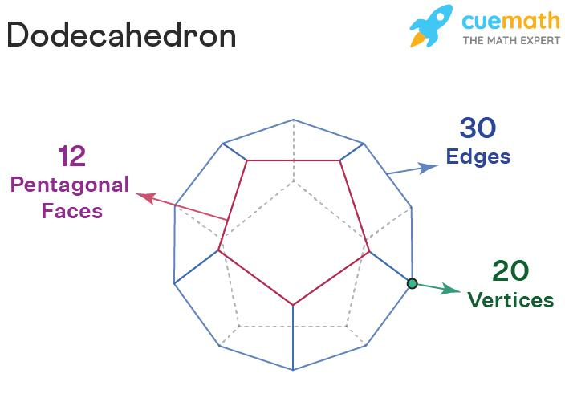
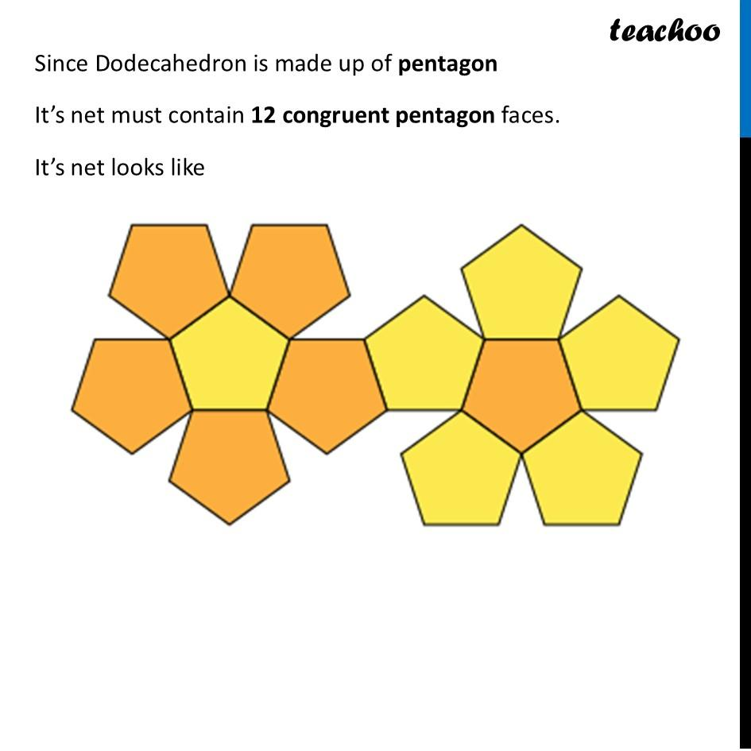

Definition
# Source: AI Source: Provided by: [Data Path: Persons Table -> ID Column: 1, Name_En Column: Motasem Essam] -> From: [ChatGPT] on [7/25/2026]
A dodecahedron is a three-dimensional polyhedron with twelve faces, thirty edges, and twenty vertices. Among the five Platonic solids, the dodecahedron is the regular dodecahedron, whose twelve faces are congruent regular pentagons.
Every face is a regular pentagon with five equal sides and five equal interior angles. Three faces meet at every vertex, and all thirty edges have the same length.
The word dodecahedron comes from Greek: dodeka means twelve, and hedron means face.

Simple Definition
# Source: AI Source: Provided by: [Data Path: Persons Table -> ID Column: 1, Name_En Column: Motasem Essam] -> From: [ChatGPT] on [7/25/2026]
A dodecahedron is a solid with twelve pentagonal faces.
For a regular dodecahedron:
- Faces: 12 regular pentagons
- Edges: 30 equal line segments
- Vertices: 20 corners
It is one of the five Platonic solids because all its faces are identical regular polygons and its vertices have the same arrangement of faces.

Key Characteristics
# Source: AI Source: Provided by: [Data Path: Persons Table -> ID Column: 1, Name_En Column: Motasem Essam] -> From: [ChatGPT] on [7/25/2026]
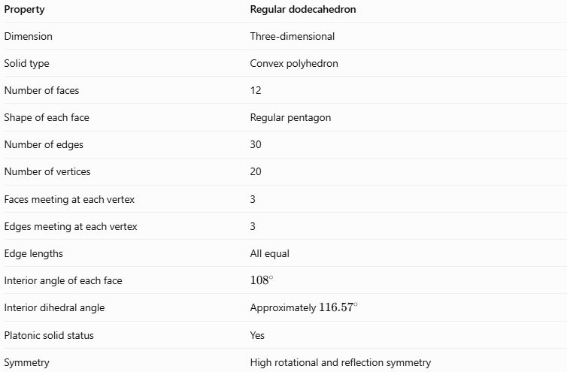
Property | Regular dodecahedron
Dimension | Three-dimensional
Solid type | Convex polyhedron
Number of faces | 12
Shape of each face | Regular pentagon
Number of edges | 30
Number of vertices | 20
Faces meeting at each vertex | 3
Edges meeting at each vertex | 3
Edge lengths | All equal
Interior angle of each face | $${108}^{∘}$$
Interior dihedral angle | Approximately ${116.57}^{∘}$
Platonic solid status | Yes
Symmetry | High rotational and reflection symmetry

Geometric Representation
# Source: AI Source: Provided by: [Data Path: Persons Table -> ID Column: 1, Name_En Column: Motasem Essam] -> From: [ChatGPT] on [7/25/2026]
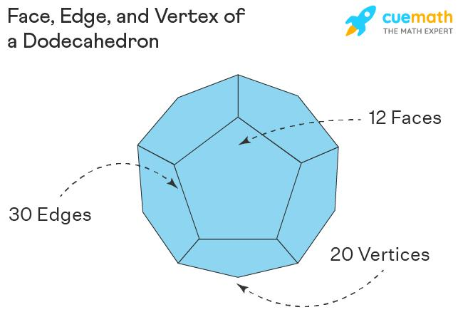
The regular dodecahedron is made entirely of pentagonal faces. Unlike a cube, whose faces are squares, the dodecahedron uses regular pentagons to form its entire boundary.
Faces
The solid has twelve congruent regular pentagonal faces. Each pentagon has:
- Five equal sides.
- Five equal interior angles of \(108^\circ\).
- Five vertices.
The sum of the interior angles of each pentagon is:
$$\left(5-2\right)×{180}^{∘}={540}^{∘}$$
Edges
Each pentagonal face has five edges, so counting face edges initially gives:
$$12×5=60$$
Each physical edge is shared by two faces. Therefore:
$$E=\frac{60}{2}=30$$
Vertices
The dodecahedron has twenty vertices. Three pentagonal faces meet at every vertex, and three edges meet there as well.

Mathematical Representations and Formulas
# Source: AI Source: Provided by: [Data Path: Persons Table -> ID Column: 1, Name_En Column: Motasem Essam] -> From: [ChatGPT] on [7/25/2026]
Let:
- $a$ = edge length
- $A_{f}$ = area of one pentagonal face
- $A_{T}$ = total surface area
- $V$ = volume
- $φ$ = golden ratio
The golden ratio is:
$$φ=\frac{1+\sqrt{5}}{2}≈1.618$$

Number of faces, edges, and vertices
# Source: AI Source: Provided by: [Data Path: Persons Table -> ID Column: 1, Name_En Column: Motasem Essam] -> From: [ChatGPT] on [7/25/2026]
For a regular dodecahedron:
$$F=12, E=30, V_{e}=20$$
Euler's formula for convex polyhedra is:
$$V_{e}-E+F=2$$
Substituting:
$$20-30+12=2$$
Therefore, the dodecahedron satisfies Euler's formula.

Area of one regular pentagonal face
# Source: AI Source: Provided by: [Data Path: Persons Table -> ID Column: 1, Name_En Column: Motasem Essam] -> From: [ChatGPT] on [7/25/2026]
The area of a regular pentagon with side length $a$ is:
$$\boxed{A_{f}=\frac{1}{4}\sqrt{25+10\sqrt{5}} a^{2}}$$
Approximately:
$$A_{f}≈1.72048a^{2}$$

Total surface area
# Source: AI Source: Provided by: [Data Path: Persons Table -> ID Column: 1, Name_En Column: Motasem Essam] -> From: [ChatGPT] on [7/25/2026]
A regular dodecahedron has twelve congruent pentagonal faces:
$$A_{T}=12A_{f}$$
Therefore:
$$\boxed{A_{T}=3\sqrt{25+10\sqrt{5}} a^{2}}$$
Approximately:
$$\boxed{A_{T}≈20.6457a^{2}}$$

Volume
# Source: AI Source: Provided by: [Data Path: Persons Table -> ID Column: 1, Name_En Column: Motasem Essam] -> From: [ChatGPT] on [7/25/2026]
The volume of a regular dodecahedron can be expressed in terms of its edge length:
$$\boxed{V=\frac{15+7\sqrt{5}}{4}a^{3}}$$
Approximately:
$$\boxed{V≈7.66312a^{3}}$$

Circumradius
# Source: AI Source: Provided by: [Data Path: Persons Table -> ID Column: 1, Name_En Column: Motasem Essam] -> From: [ChatGPT] on [7/25/2026]
The circumradius is the distance from the center of the solid to any vertex. For a regular dodecahedron:
$$\boxed{R=\frac{\sqrt{3}}{4}\left(1+\sqrt{5}\right)a}$$

Inradius
# Source: AI Source: Provided by: [Data Path: Persons Table -> ID Column: 1, Name_En Column: Motasem Essam] -> From: [ChatGPT] on [7/25/2026]
The inradius is the perpendicular distance from the center to any face. For a regular dodecahedron:
$$\boxed{r=\frac{a}{20}\sqrt{250+110\sqrt{5}}}$$

Total edge length
# Source: AI Source: Provided by: [Data Path: Persons Table -> ID Column: 1, Name_En Column: Motasem Essam] -> From: [ChatGPT] on [7/25/2026]
Since there are thirty equal edges:
$$\boxed{L=30a}$$

Worked Examples
# Source: AI Source: Provided by: [Data Path: Persons Table -> ID Column: 1, Name_En Column: Motasem Essam] -> From: [ChatGPT] on [7/25/2026]
Example 1: Counting geometric elements
Problem: How many faces, edges, and vertices does a regular dodecahedron have?
Solution:
- Faces: $F=12$
- Edges: $E=30$
- Vertices: $V_{e}=20$
Check Euler's formula:
$$20-30+12=2$$
Answer: 12 faces, 30 edges, and 20 vertices.
Example 2: Calculating the area of one face
Problem: A regular dodecahedron has an edge length of $2\text{ cm}$. Find the area of one pentagonal face.
Formula:
$$A_{f}=\frac{1}{4}\sqrt{25+10\sqrt{5}} a^{2}$$
Substitute $a=2$:
$$A_{f}=\frac{1}{4}\sqrt{25+10\sqrt{5}}{\left(2\right)}^{2}$$
$$A_{f}=\sqrt{25+10\sqrt{5}}$$
Answer:
$$\boxed{A_{f}≈6.88{\text{ cm}}^{2}}$$
Example 3: Calculating total surface area
Problem: Find the total surface area of a regular dodecahedron with edge length $2\text{ cm}$.
Formula:
$$A_{T}=3\sqrt{25+10\sqrt{5}} a^{2}$$
Substitute $a=2$:
$$A_{T}=12\sqrt{25+10\sqrt{5}}$$
Answer:
$$\boxed{A_{T}≈82.58{\text{ cm}}^{2}}$$
Example 4: Calculating volume
Problem: Find the volume of a regular dodecahedron with edge length $2\text{ cm}$.
Formula:
$$V=\frac{15+7\sqrt{5}}{4}a^{3}$$
Substitute $a=2$:
$$V=\frac{15+7\sqrt{5}}{4}\left(8\right)$$
$$V=2\left(15+7\sqrt{5}\right)$$
Answer:
$$\boxed{V≈61.30{\text{ cm}}^{3}}$$
Example 5: Finding the total edge length
Problem: Each edge of a regular dodecahedron is $3\text{ cm}$ long. Find the sum of all its edge lengths.
Formula:
$$L=30a$$
Substitute:
$$L=30\left(3\right)$$
Answer:
$$\boxed{L=90\text{ cm}}$$

Comparison with Related Geometric Solids
# Source: AI Source: Provided by: [Data Path: Persons Table -> ID Column: 1, Name_En Column: Motasem Essam] -> From: [ChatGPT] on [7/25/2026]
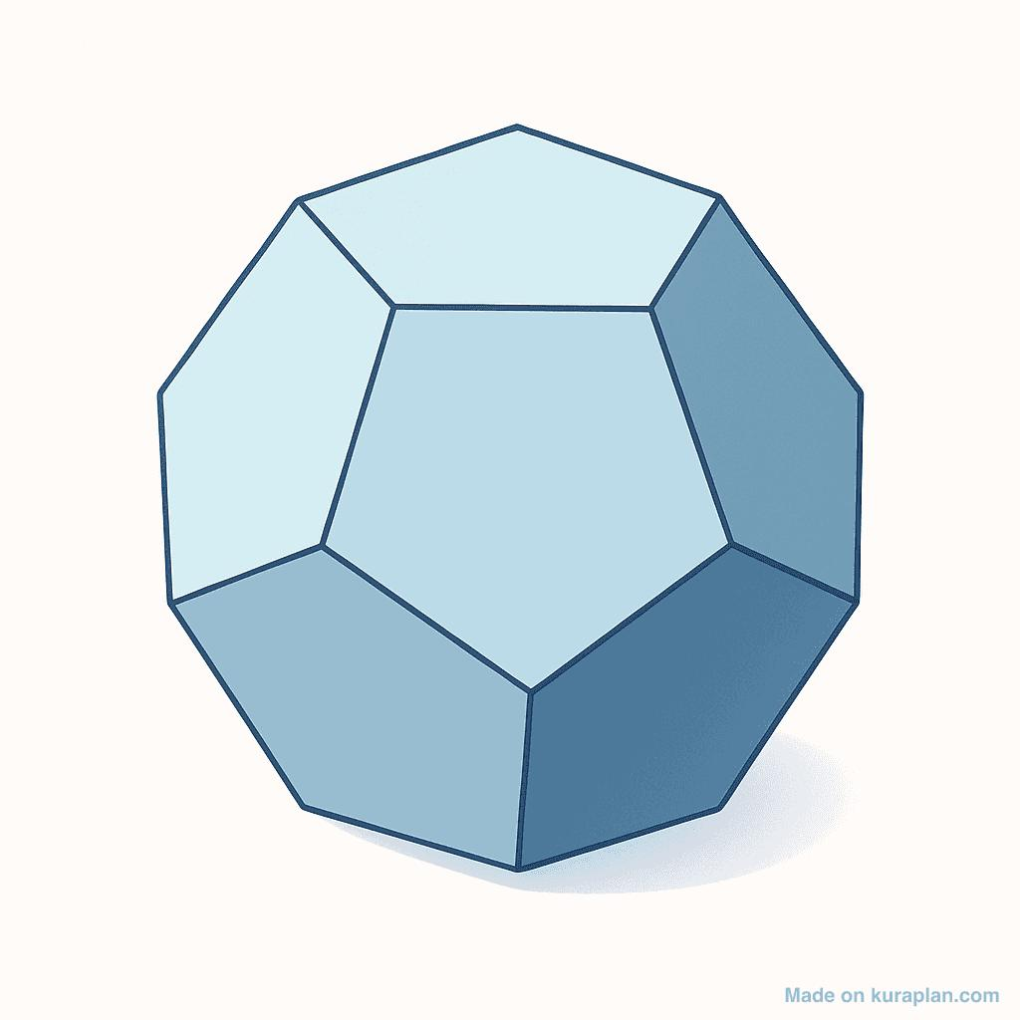
Dodecahedron
12 faces · 30 edges · 20 vertices
A regular dodecahedron has twelve regular pentagonal faces.
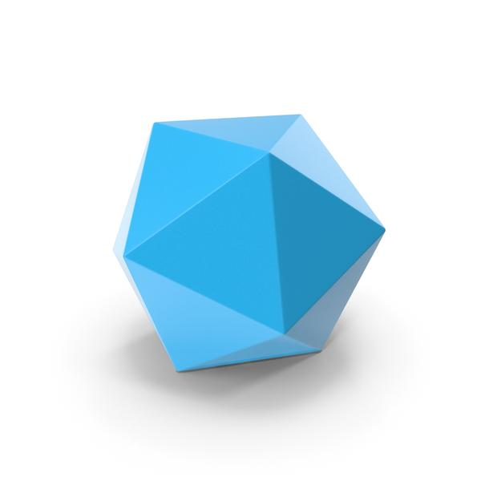
Icosahedron
20 faces · 30 edges · 12 vertices
Its faces are equilateral triangles. It has the same number of edges as a regular dodecahedron but different numbers of faces and vertices.
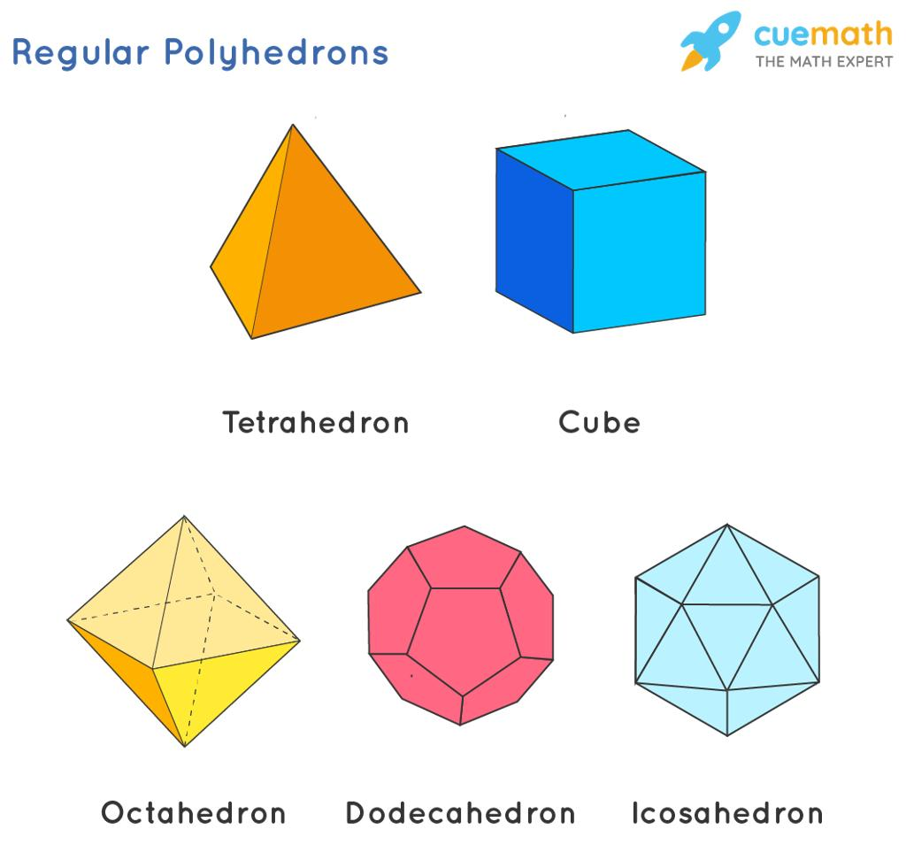
Cube (Hexahedron)
6 faces · 12 edges · 8 vertices
Its faces are squares, with three faces meeting at every vertex.
The dodecahedron and icosahedron are dual Platonic solids. In this relationship, the centers of the faces of one solid correspond to the vertices of the other. The dodecahedron's twelve faces correspond to the icosahedron's twelve vertices, and its twenty vertices correspond to the icosahedron's twenty faces.

The Dodecahedron Among the Five Platonic Solids
# Source: AI Source: Provided by: [Data Path: Persons Table -> ID Column: 1, Name_En Column: Motasem Essam] -> From: [ChatGPT] on [7/25/2026]
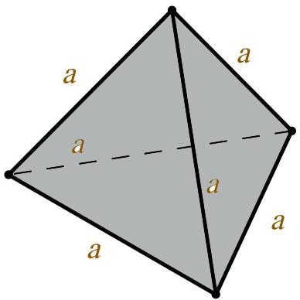
1. Tetrahedron
4 triangular faces
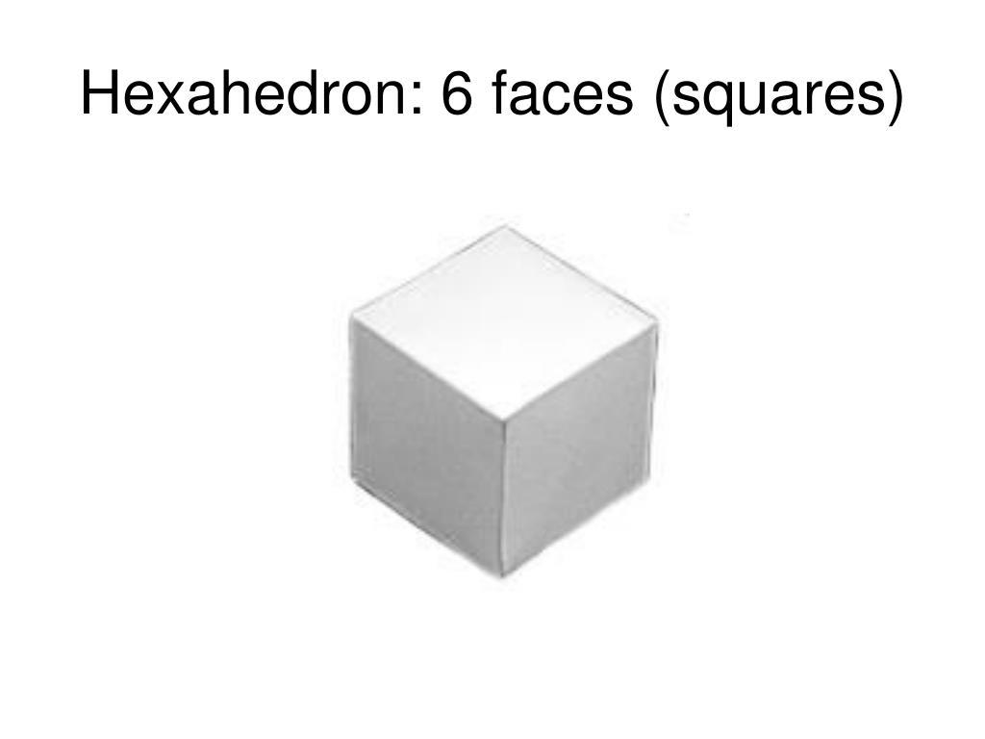
2. Cube (Hexahedron)
6 square faces
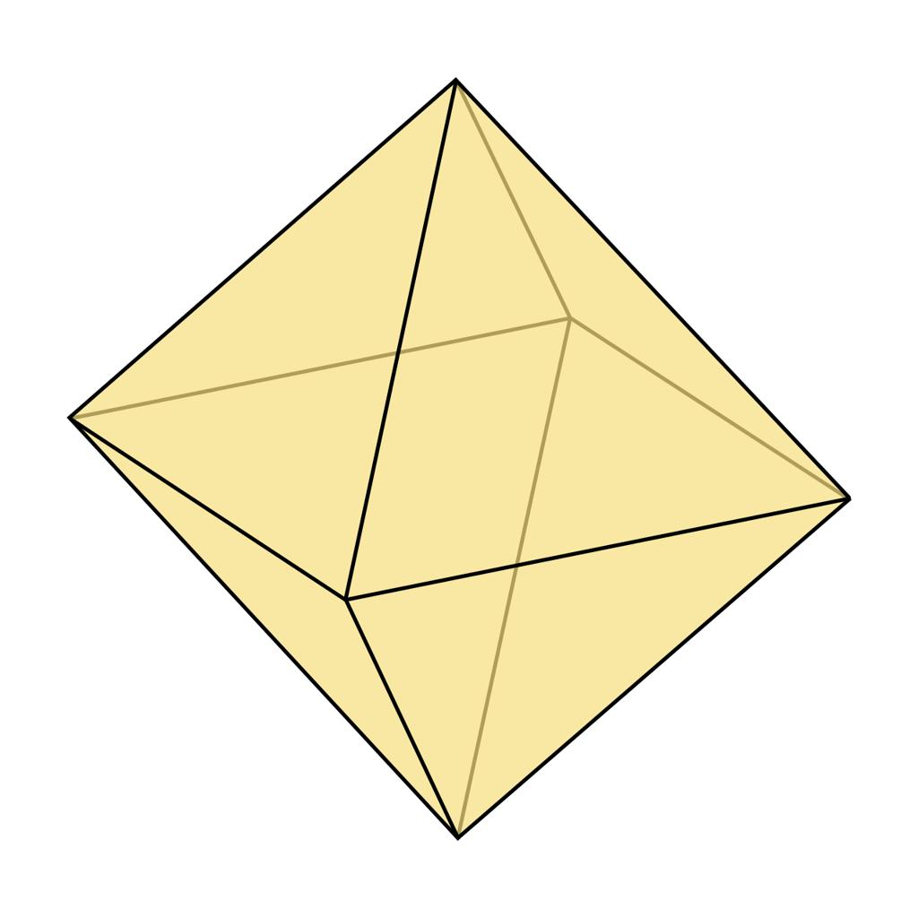
3. Octahedron
8 triangular faces
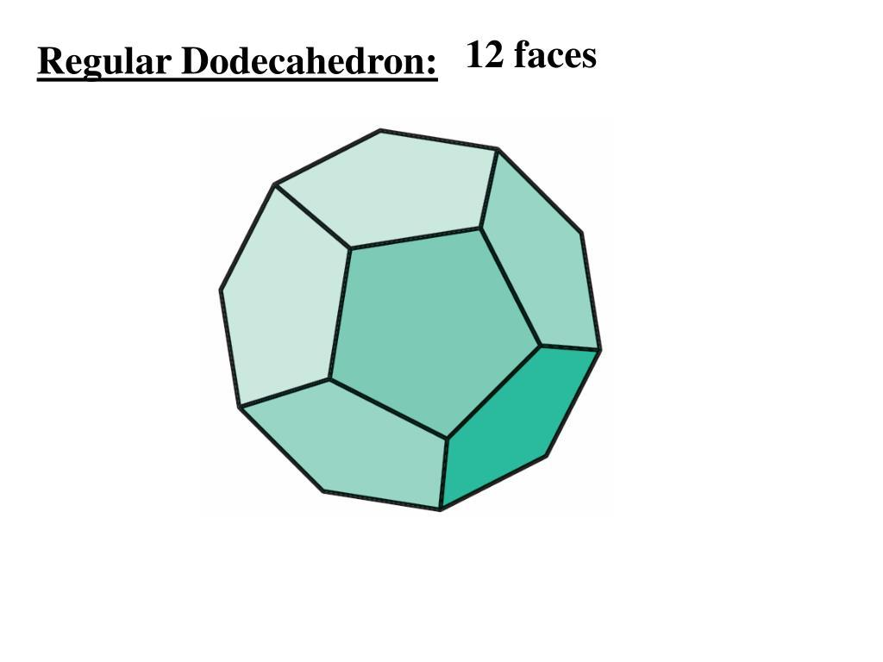
4. Dodecahedron
12 pentagonal faces
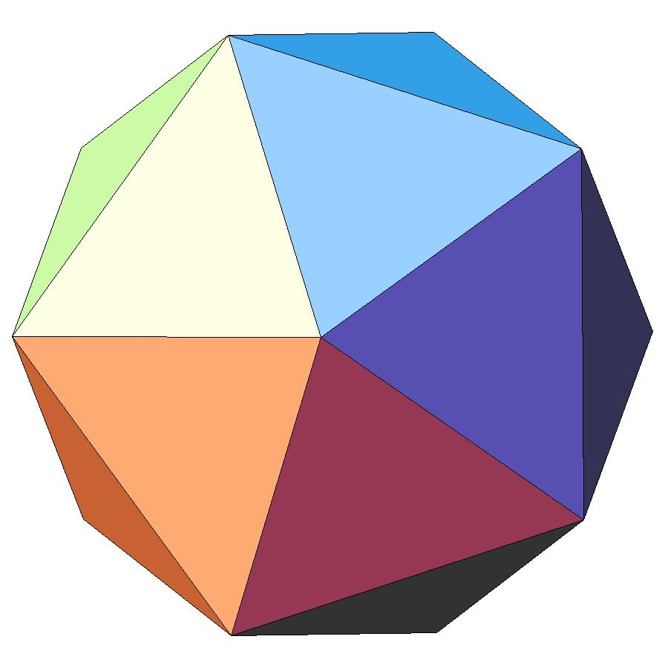
5. Icosahedron
20 triangular faces
The dodecahedron is the only Platonic solid whose faces are regular pentagons. It has more faces and edges than the tetrahedron, cube, and octahedron.

Constructing Dodecahedron in Solid Geometry

Instruments Used
# Source: AI Source: Provided by: [Data Path: Persons Table -> ID Column: 1, Name_En Column: Motasem Essam] -> From: [ChatGPT] on [7/25/2026]
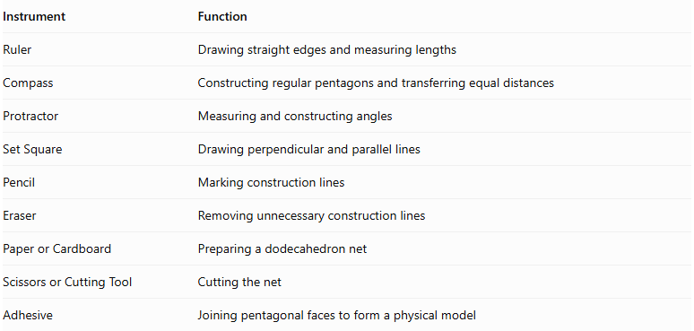
Instrument | Function
Ruler | Drawing straight edges and measuring lengths
Compass | Constructing regular pentagons and transferring equal distances
Protractor | Measuring and constructing angles
Set Square | Drawing perpendicular and parallel lines
Pencil | Marking construction lines
Eraser | Removing unnecessary construction lines
Paper or Cardboard | Preparing a dodecahedron net
Scissors or Cutting Tool | Cutting the net
Adhesive | Joining pentagonal faces to form a physical model

Construction Procedures

A. Face-Based Construction
# Source: AI Source: Provided by: [Data Path: Persons Table -> ID Column: 1, Name_En Column: Motasem Essam] -> From: [ChatGPT] on [7/25/2026]
- Construct a regular pentagon using a compass and ruler.
- Determine the required edge length.
- Construct twelve congruent regular pentagonal faces.
- Arrange the pentagons according to the adjacency of a regular dodecahedron.
- Connect corresponding edges of neighboring pentagons.
- Ensure that three pentagonal faces meet at each vertex.
- Complete the solid and distinguish visible edges from hidden edges.
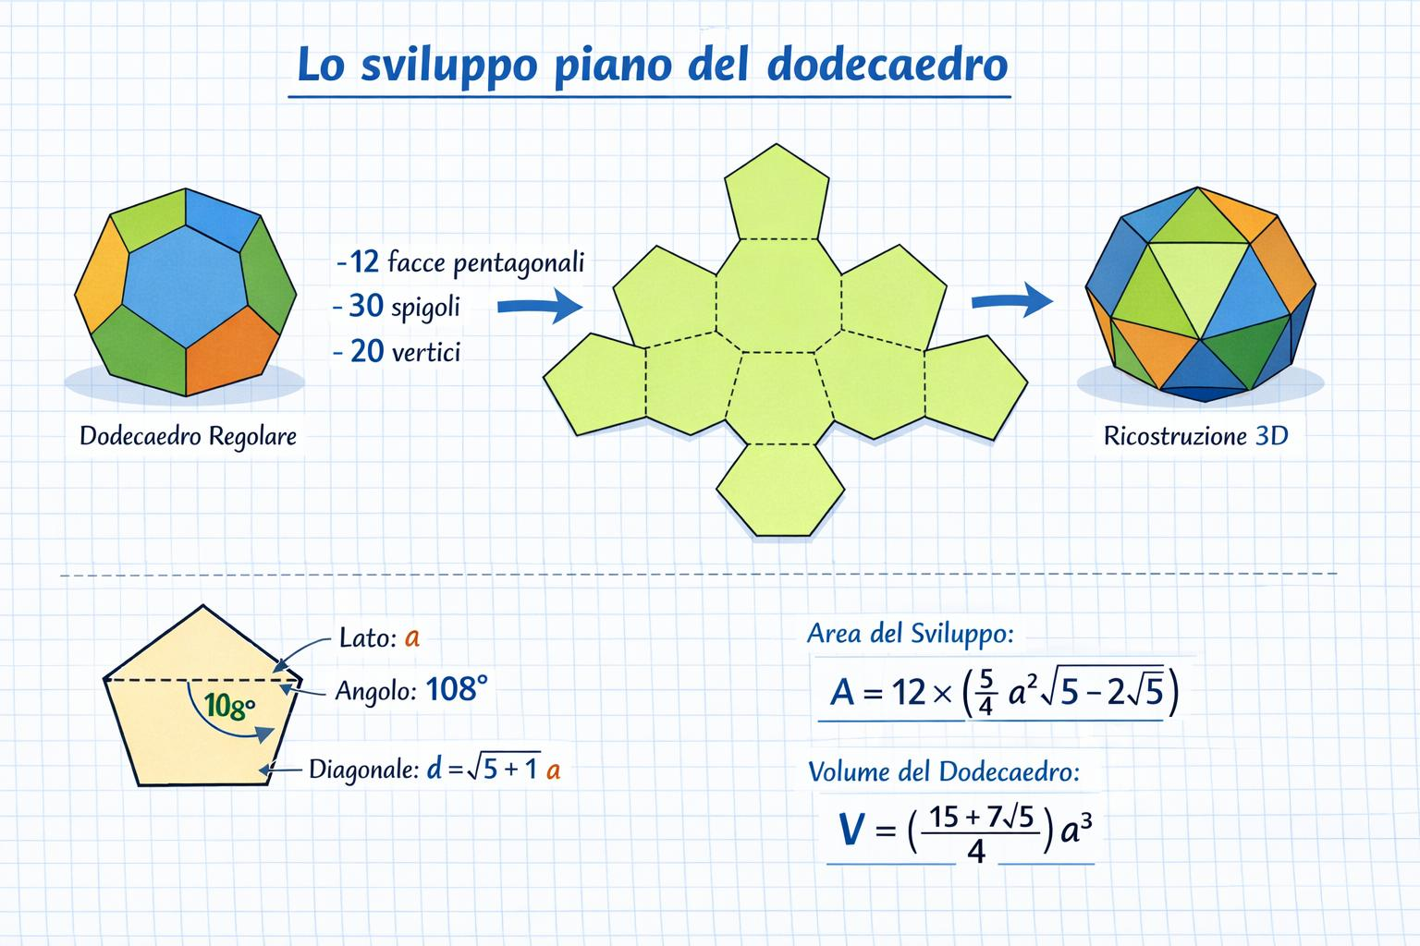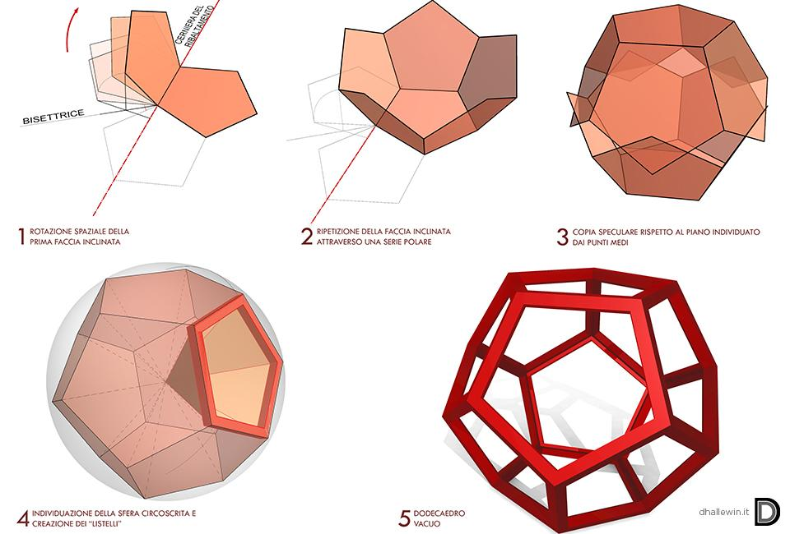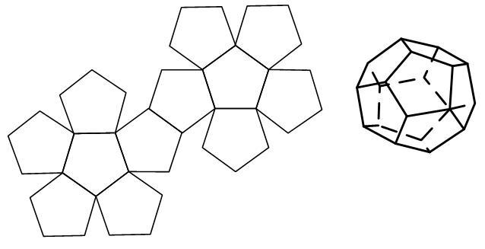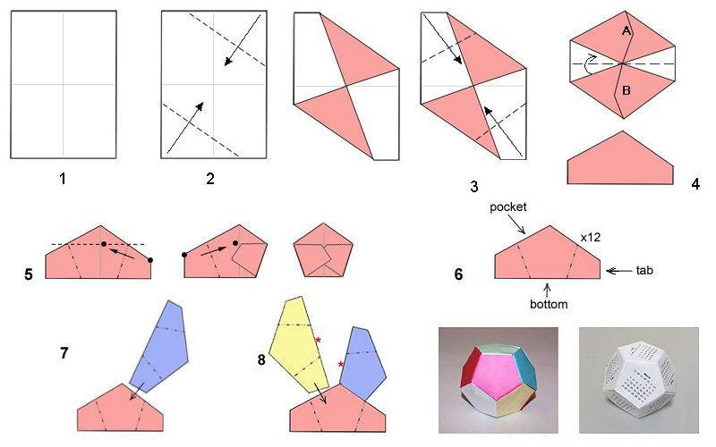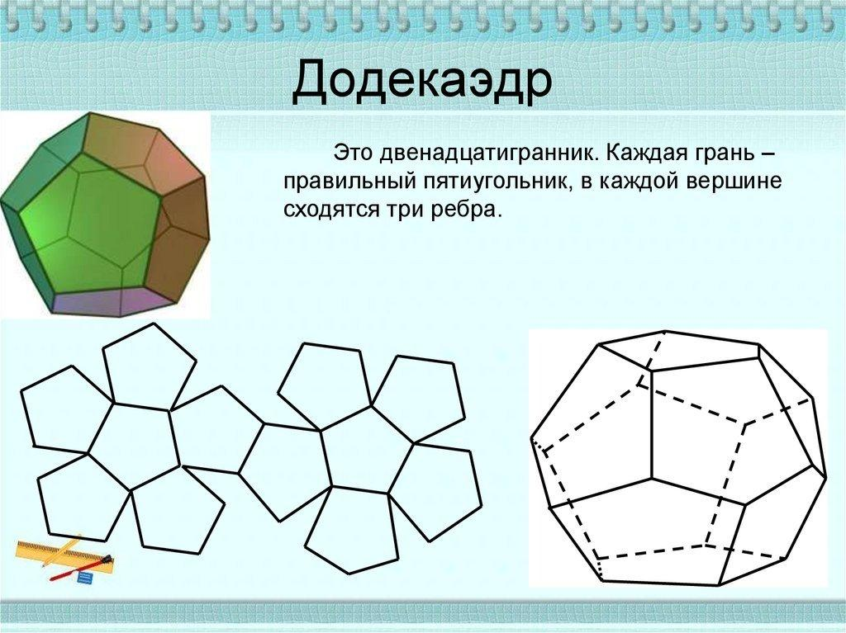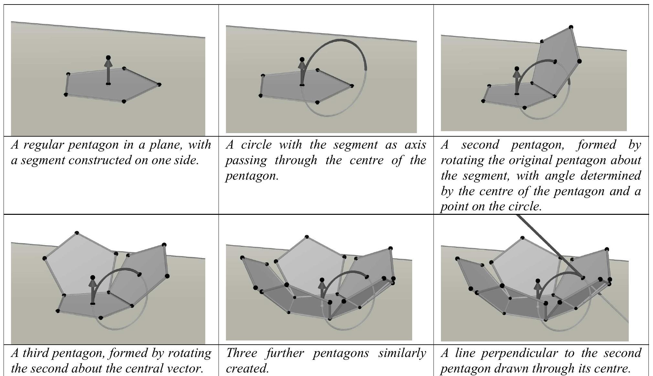

B. Edge-Based Construction
# Source: AI Source: Provided by: [Data Path: Persons Table -> ID Column: 1, Name_En Column: Motasem Essam] -> From: [ChatGPT] on [7/25/2026]
- Determine the required edge length.
- Construct thirty equal-length edges.
- Arrange the edges according to the dodecahedron's pentagonal face structure.
- Form twelve closed pentagonal boundaries.
- Connect the pentagonal faces along their shared edges.
- Verify that each edge belongs to exactly two faces.
- Check that three faces meet at each vertex.

C. Vertex-Based Construction
# Source: AI Source: Provided by: [Data Path: Persons Table -> ID Column: 1, Name_En Column: Motasem Essam] -> From: [ChatGPT] on [7/25/2026]
- Establish the twenty vertices of the dodecahedron using geometric construction relationships.
- Arrange the vertices according to the solid's pentagonal structure.
- Identify the thirty pairs of adjacent vertices.
- Connect each adjacent pair to form an edge.
- Complete the twelve pentagonal faces.
- Verify that three edges meet at every vertex.

D. Net-Based Construction
# Source: AI Source: Provided by: [Data Path: Persons Table -> ID Column: 1, Name_En Column: Motasem Essam] -> From: [ChatGPT] on [7/25/2026]
- Draw twelve congruent regular pentagons.
- Arrange the pentagons into a valid connected dodecahedron net.
- Ensure that each pentagon is connected to its neighboring faces along complete edges.
- Add joining tabs if preparing a physical model.
- Cut out the net.
- Fold along the shared edges.
- Join the corresponding edges to form the closed dodecahedron.
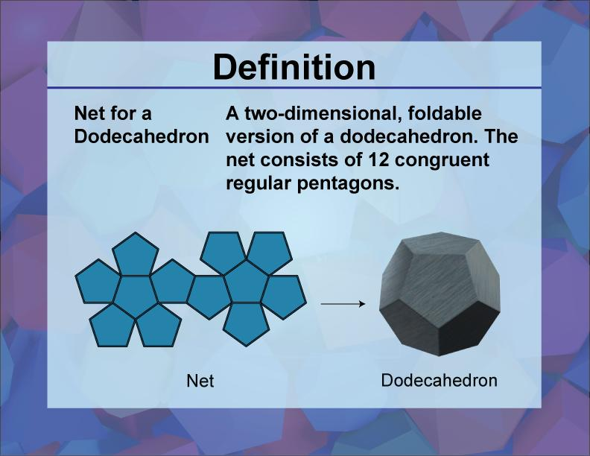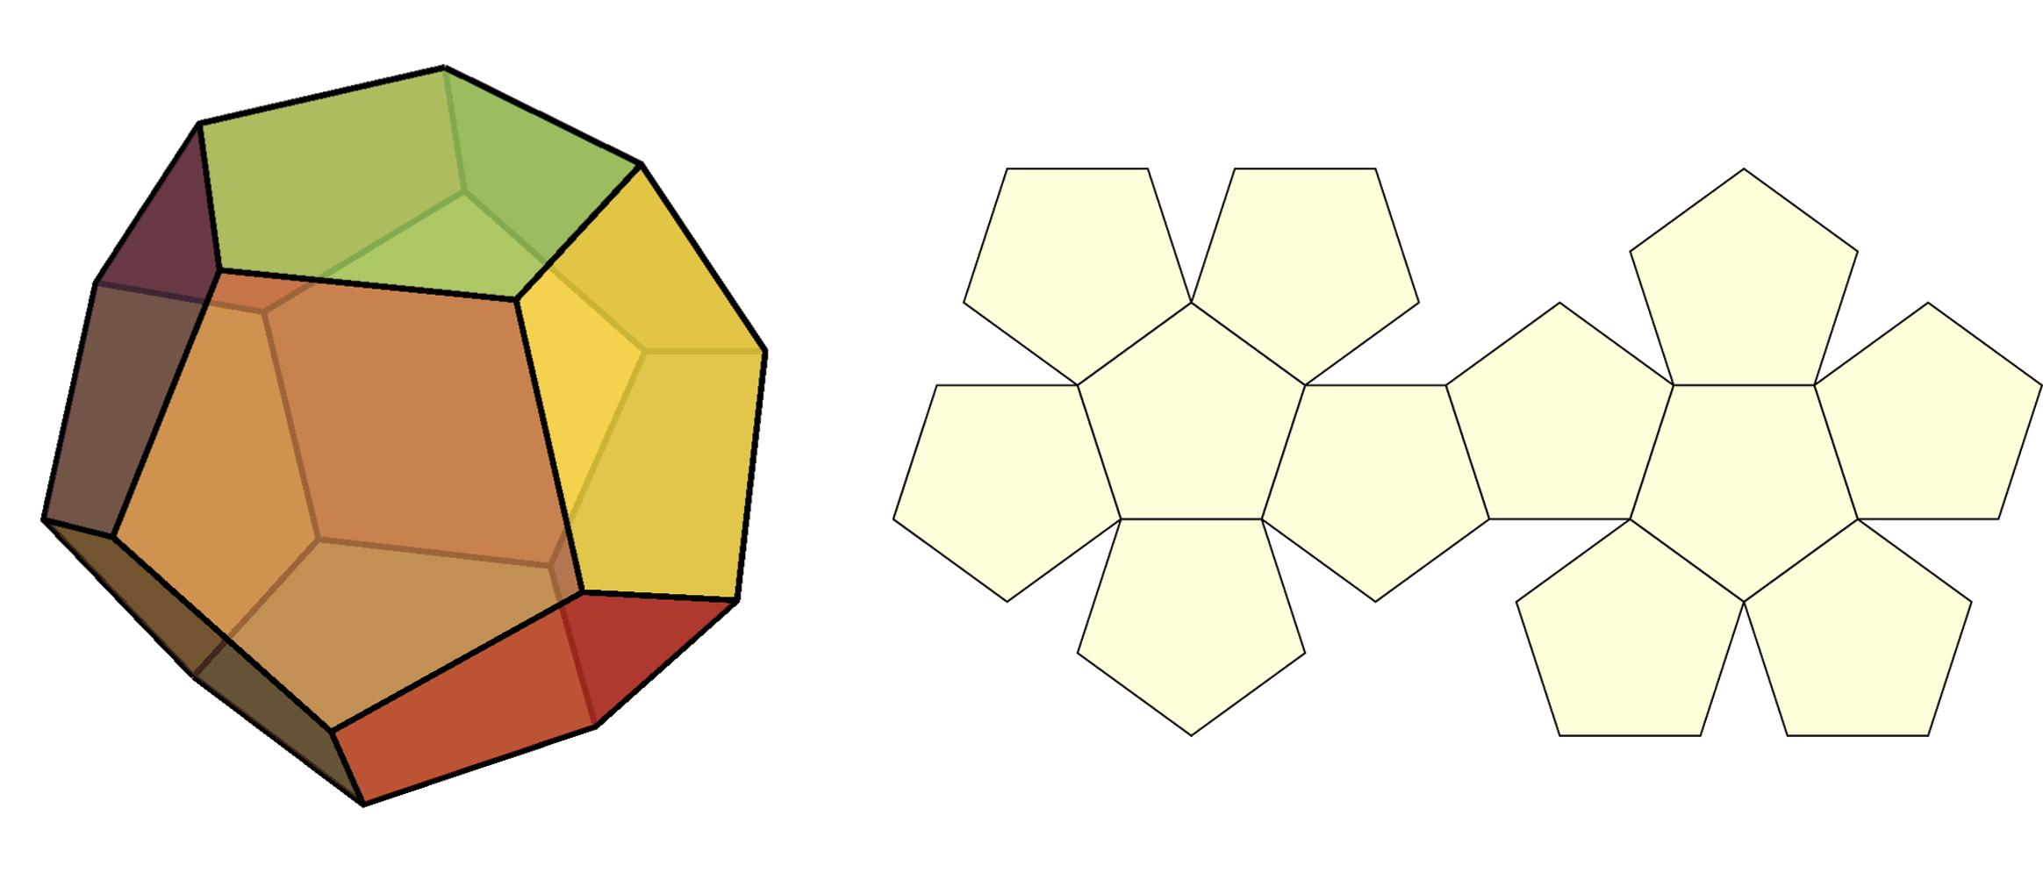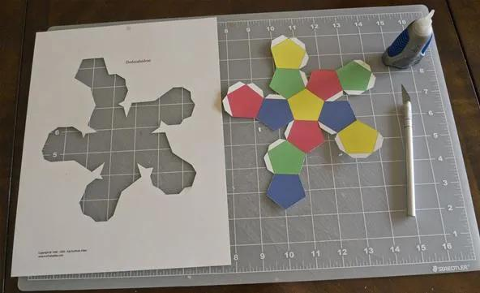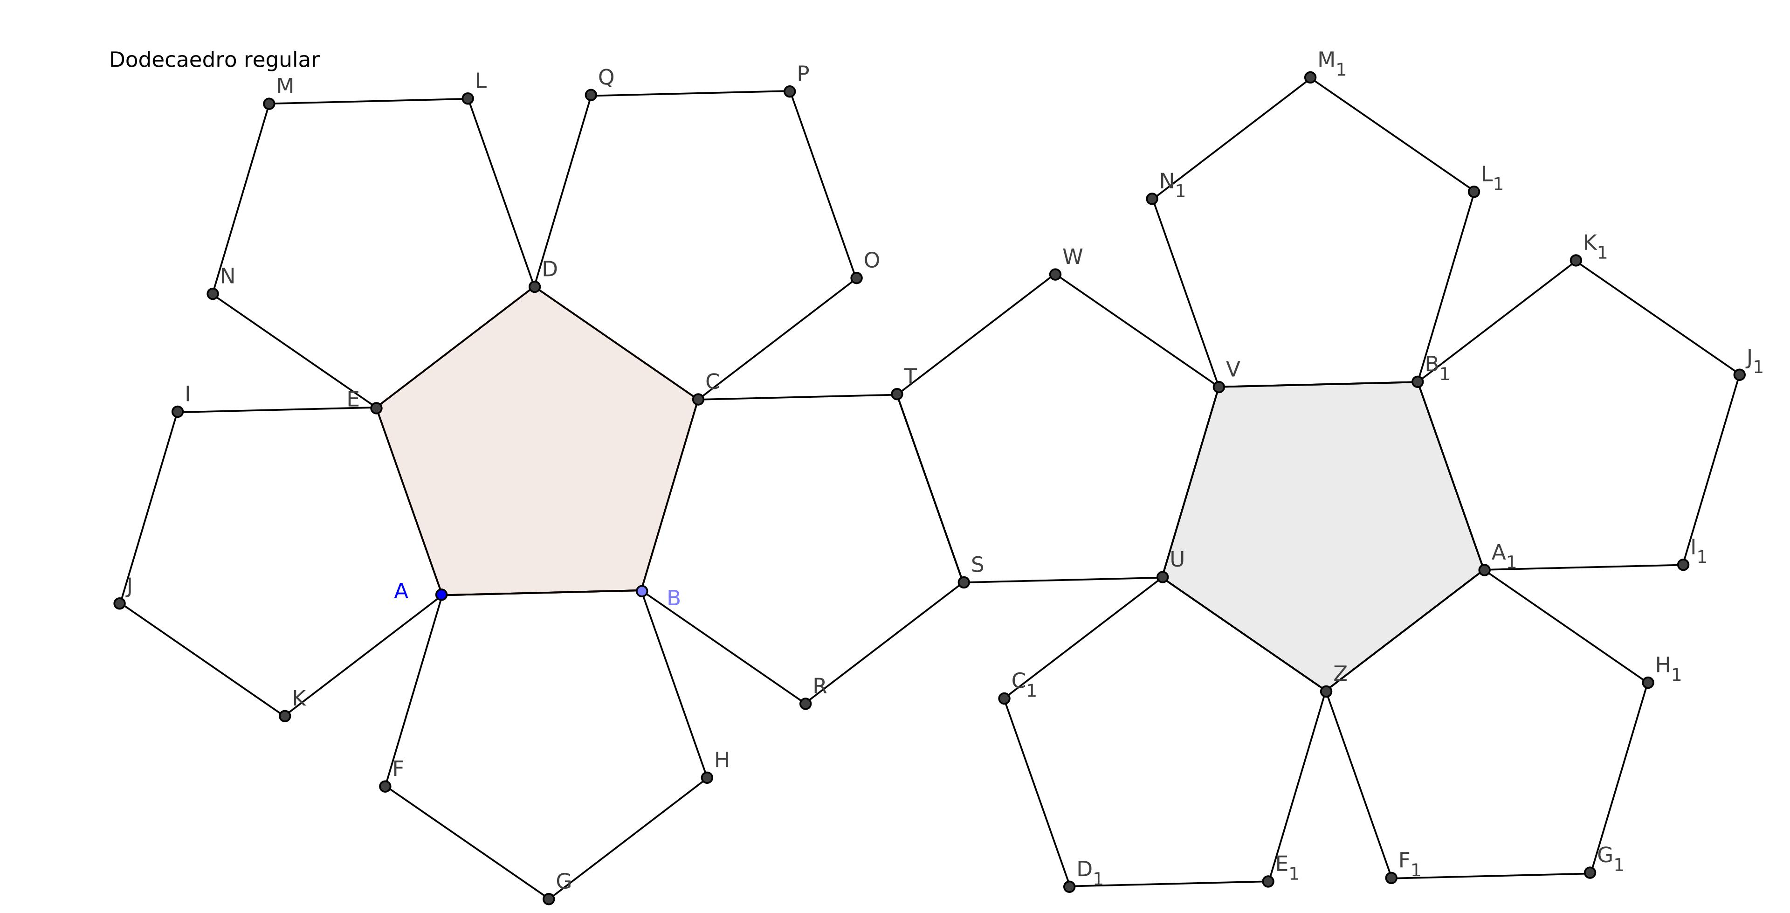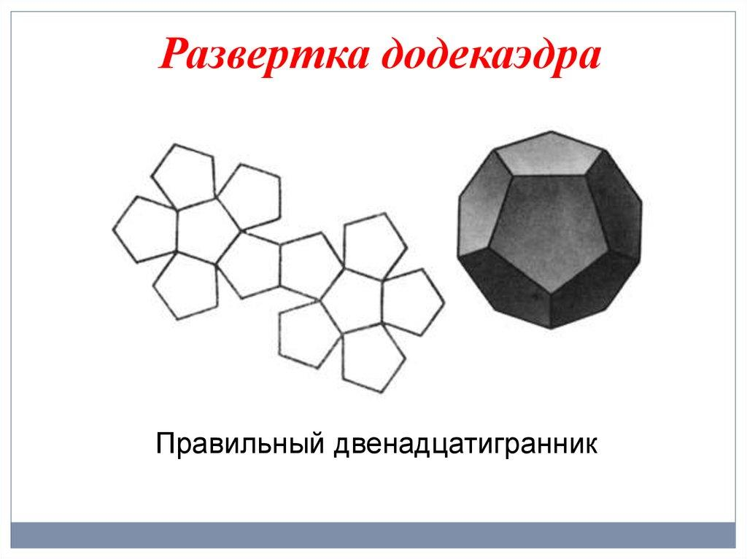

E. Physical Model Construction
# Source: AI Source: Provided by: [Data Path: Persons Table -> ID Column: 1, Name_En Column: Motasem Essam] -> From: [ChatGPT] on [7/25/2026]
- Prepare twelve congruent regular pentagonal pieces or a suitable dodecahedron net.
- Measure and cut all pentagonal pieces to equal dimensions.
- Arrange the pentagonal faces according to the dodecahedron structure.
- Join neighboring faces along their corresponding edges.
- Close the solid by connecting the remaining open edges.
- Verify that the completed model has twelve faces, thirty edges, and twenty vertices.

Applications of the Dodecahedron
# Source: AI Source: Provided by: [Data Path: Persons Table -> ID Column: 1, Name_En Column: Motasem Essam] -> From: [ChatGPT] on [7/25/2026]
- Mathematics and geometry: illustrates regular polygons, symmetry, polyhedral structure, and Euler's formula.
- Board games and dice: twelve-sided geometric forms are used in gaming; a regular dodecahedron is a common shape for a twenty-sided die only if it is actually an icosahedron, so the distinction between these solids matters.
- Architecture and design: dodecahedral forms can inspire decorative structures and geometric models.
- Computer graphics: useful in 3D modeling, mesh design, and representations of complex polyhedra.
- Science and molecular modeling: dodecahedral arrangements appear in some molecular cages and other scientific structures.
- Education: physical models help students understand how pentagons join to create a closed three-dimensional surface.

Key Points
# Source: AI Source: Provided by: [Data Path: Persons Table -> ID Column: 1, Name_En Column: Motasem Essam] -> From: [ChatGPT] on [7/25/2026]
- A dodecahedron is a polyhedron with twelve faces.
- The regular dodecahedron is one of the five Platonic solids.
- It has 12 regular pentagonal faces, 30 equal edges, and 20 vertices.
- Three faces meet at every vertex.
- Each pentagonal face has interior angles of ${108}^{∘}$.
- Total surface area: $A_{T}=3\sqrt{25+10\sqrt{5}} a^{2}$.
- Volume: $V=\frac{15+7\sqrt{5}}{4}a^{3}$.
- Its dual Platonic solid is the icosahedron.
- It satisfies Euler's formula: $V_{e}-E+F=2$.

Conclusion
# Source: AI Source: Provided by: [Data Path: Persons Table -> ID Column: 1, Name_En Column: Motasem Essam] -> From: [ChatGPT] on [7/25/2026]
The dodecahedron is one of the five Platonic solids and is distinguished by its twelve congruent regular pentagonal faces. Its thirty equal edges, twenty vertices, and high degree of symmetry make it an important example in the study of three-dimensional geometry. Its relationship with the icosahedron also demonstrates the idea of duality between polyhedra.

